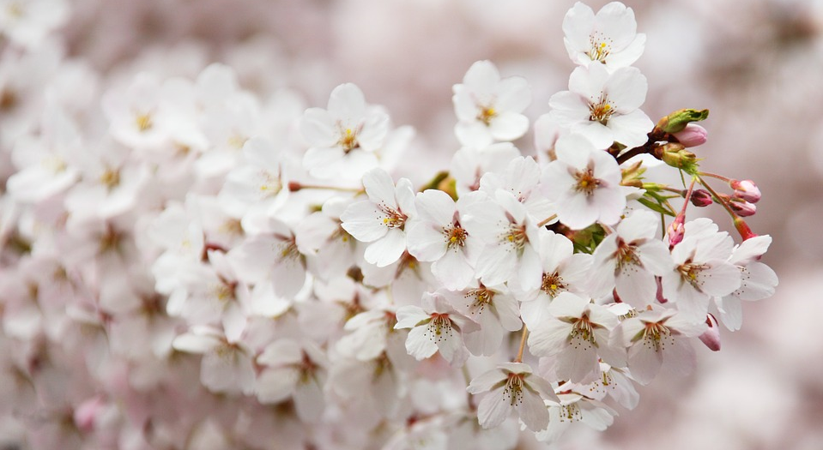

We think of the environment and your comfort
You have chosen a Green Key awarded establishment. This means that you are automatically helping to preserve the environment, as we meet Green Key’s stringent environmental requirements.
We make it easier for you to care for the environment without diminishing your comfort.

