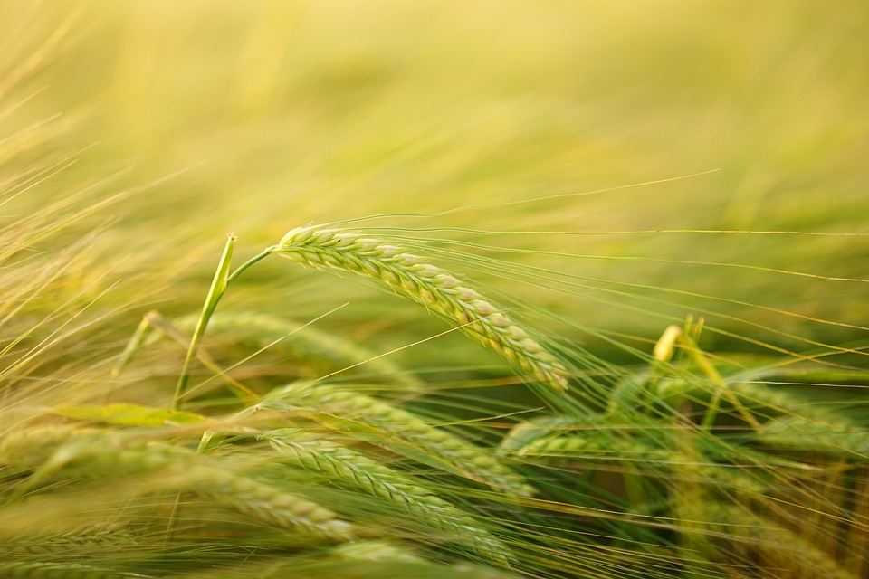

World Food Day – 16 October
Our daily choices of food have a local as well as a global effect. As a Green Key awarded establishment, we do our best to give you the opportunity to eat responsibly when staying with us.

