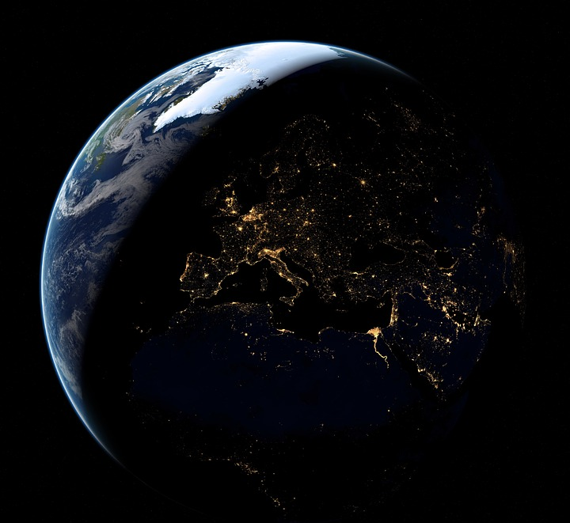

Earth Hour – Date, 8.30pm
Let us protect our planet together! As a Green Key certified establishment, we make special efforts to preserve the environment every day. On XXX between 8.30 pm and 9.30 pm, we celebrate Earth Hour by turning down lights for one hour. Please, join us! Make climate friendly choices at our restaurant or turn off excess lights.

