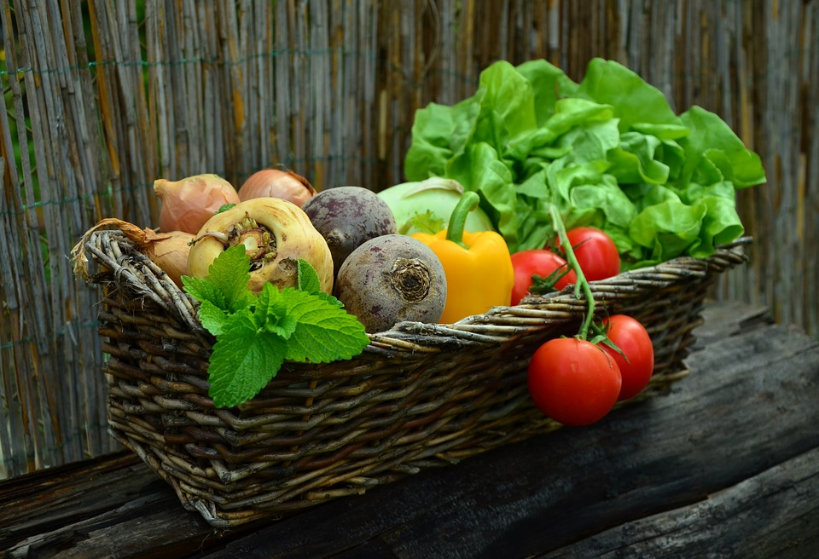

Enjoy seasonal specialties
As a Green Key awarded establishment, we make special effort to preserve the environment. We make food in an environmentally friendly way using organic, seasonal and/or local products. We want to make it easy for you to care for the environment – also when you eat – while giving you good, intriguing taste experiences.

