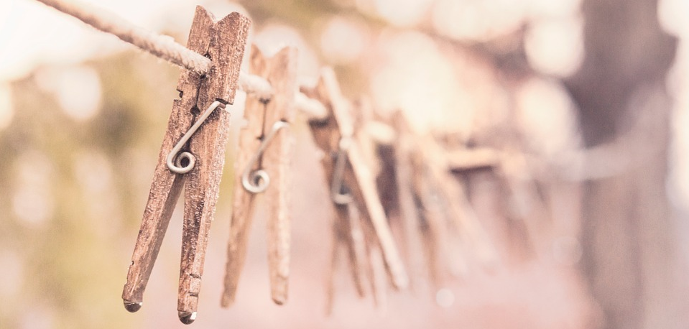

We save water
As a Green Key establishment, we make special efforts to preserve the environment. We want to make it easy for you to reuse towels without diminishing your comfort. By hanging up your towel, you indicate that you will use it another day and it will not be replaced.
This way we help save nature together.

