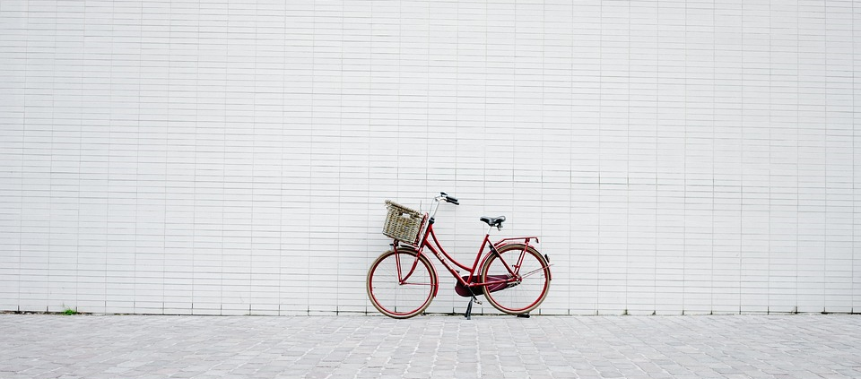

We support sustainable mobility
As a Green Key awarded establishment, we make special efforts to preserve the environment. Bus, train, metro and bicycles are environmentally friendly alternatives to regular cars.

We want to make it easy for you to use environmentally friendly forms of transport. See our website, the information in your room or ask at reception for information about public transport, biking and walking routes.

