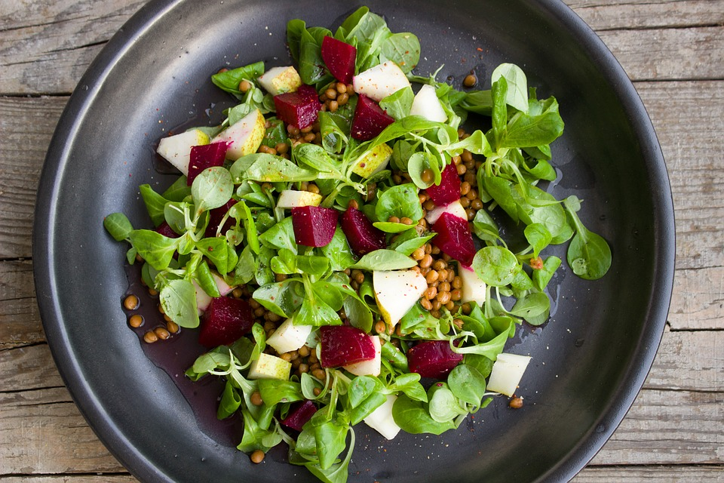

World Vegan Day – 1 November
Go vegan!
On World Vegan Day, we encourage you to try vegan foods. As a Green Key certified establishment, we always serve vegetarian food and plenty of organic and local products. Please ask staff for our vegan options.

